**Political economy regimes and the decarbonisation challenge**

Journals: Nature sustainability (perspective?), Global Sustainability, World Development, ?

1. **Introduction**

Pre-amble

* Deep decarbonisation depends on various endogenous social, political and institutional factors. [cite examples, recognition in the literature]. Naturally, suggestions to muster political will, strengthen institutions, and train technocratic capabilities follow.
* Yet, it is important to recognise these as factors that may be highly resistant to change. In some cases, institutions have been deliberately hamstrung … Examples: kleptocracies, rentier states. These regime architectures explain the persistence of political economic challenges, even in the face of concerted efforts at reform in specific problem areas (fossil fuel subsidies?)
* Shouldn’t misunderstand the development process … democratic bias… no slow progress towards democracy, capable institutions and climate-aware citizens … but a landscape of distinct regime types (Levitsky and Way 2002)… punctuated by periodic upheavals, but otherwise quite stable.

Relevance for climate research

* Important to understand these regimes and the landscape of risks they pose to a global energy transition. In the post-Paris period, targets must now be substantiated with action, and some regimes will be more prone to action than others.
* SSPs suggest quite a few things matter – fossil fuels, delay, cooperation, rivalry. But scenarios are not enough, we should seek to should understand which worlds are more likely and how we can shift between them.

Outline approach

* In this paper we focus on three overarching state conditions: vested interests, state capacities, and social cohesion. These are things that matter for a world in which major investments and potential revenues have to be foregone, with a major disruption to the status quo, and where long-term perspective and integrative approaches are needed to deal with trade-offs (willingness, ability, and consequences). Complexity and trade-offs increase with **ambition** and **delay**. Link to SDG literature…
* Examine the distribution of these factors, overlap with mitigation bottlenecks, .. etc.
* Aim towards a typology of mitigation risk, in contrast to the dominant focus of country groupings on income, development status and drivers of carbon emissions (Victor, Gerlagh, & Baiocchi, 2014). Such a map of political economic challenges to mitigation would be useful to inform policy strategies, sense-check scenario designs, contextualise case study research, and so forth.

1. **Structural barriers to deep decarbonisation**

* Political economic analysis of climate mitigation barriers is a growing field of inquiry. Emphasis is on vested interests and institutions. [cite and summarise major overview papers: (Newell & Mulvaney, 2013; O’Hara, 2009; Paterson & P‐Laberge, 2018; Vogt-Schilb & Hallegatte, 2017)].
* Different lenses needed (transitions theory)… global trends/national contexts/niche activities. Altogether this makes it a difficult task to track empirical effects…
* Fossil subsidy reform? (Victor)

Hammond, G. P., & Pearson, P. J. G. (2012). Challenges of the transition to a low carbon, more electric future: From here to 2050. *Energy Policy*, *52*, 1–9. http://doi.org/10.1016/j.enpol.2012.10.052

Sovacool, B. K. (2012). The political economy of energy poverty: A review of key challenges. *Energy for Sustainable Development*, *16*(3), 272–282. http://doi.org/10.1016/j.esd.2012.05.006

* 1. *Vested interests*

Sovacool, B. K. (2014). What are we doing here? Analyzing fifteen years of energy scholarship and proposing a social science research agenda. *Energy Research and Social Science*, *1*, 1–29. http://doi.org/10.1016/j.erss.2014.02.00

Vogt-Schilb, A., & Hallegatte, S. (2017). Climate policies and nationally determined contributions: reconciling the needed ambition with the political economy. *Wiley Interdisciplinary Reviews: Energy and Environment*, *e256*. http://doi.org/10.1002/wene.256

Geels, F. W., Sovacool, B. K., Schwanen, T., & Sorrell, S. (2017). The Socio-Technical Dynamics of Low-Carbon Transitions. *Joule*, 1–17. http://doi.org/10.1016/j.joule.2017.09.018

Moe

F. van der Ploeg, “Fossil fuel producers under threat,” *Oxford Rev. Econ. Policy*, vol. 32, no. 2, pp. 206–222, 2016.

* 1. *Institutional capacity*
* Analogues to the development field: how to explain the slow pace of growth, infrastructure provisioning, and poverty alleviation? Institutions again have a central role … goes back to colonial history …

Acemoglu & colonial development

* 1. *Social cohesion*

Easterly, W., Ritzan, J., & Woolcock, M. (2006). *Social Cohesion, Institutions, and Growth* (No. 94).

*Definition: “the nature and extent of social and economic divisions within a society (income, ethnicity, political party, caste, language, …)”. Fewer divisions = fewer “leverage points for individuals, groups, or events to expose and exacerbate social fault lines”*

*Example: right-wing populism and climate change (Lockwood 2018), manifesting in Trump’s withdrawal from the Paris Agreement*

* 1. *Others*
* Ideology/ideas. External conflicts. Democracy.

1. **Regime types**

* What seems to be missing from these discussions is assessments of how these problems are interlinked – Geels.
* Developmental states, welfare states, fragile states. (similar effort for adaptation: Barnett & Adger 2007)
* *Sen Development as freedom (p40): interlocking role of institutions, social cohesion, social provisioning*

“The assumption that hybrid regimes [partial democracies] are (or should be) moving in a democratic direction lacks empirical foundation… these cases should be conceptualized for what they are: a distinct, nondemocratic regime type.” (Levitsky and Way 2002)

**Also: that provisioning, institutions and cohesion are seen here in an instrumental fashion should not reduce their intrinsic importance as public goods (Sen p37)**

1. **Methods**
   1. *Data*

|  |  |  |  |
| --- | --- | --- | --- |
| Indicator | Description | n | Source |
| **Vested interests**  Total natural resources rents  **State capacities**  Government corruption  Government effectiveness  **Social cohesion**  Gini index  Fractionalisation | Difference between the value of resource production (coal, oil, gas, forestry, minerals) and total costs of production, as a % of GDP.  Standardised estimates of governance, from multiple qualitative sources  Deviation of income distribution from an equal distribution  Probability of two random individuals belonging to different ethnic groups | 187  206  206  184  186 | World Bank  WGI  WGI  SWIID  Alesina et al. 2003 |

* 1. *Cluster analysis*

Correspondence analysis (Koch & Fritz, 2014)

DFMA?? (Fritz & Koch, 2016)

* 1. *Stylized facts*

1. **Results**
   1. *Correlations*

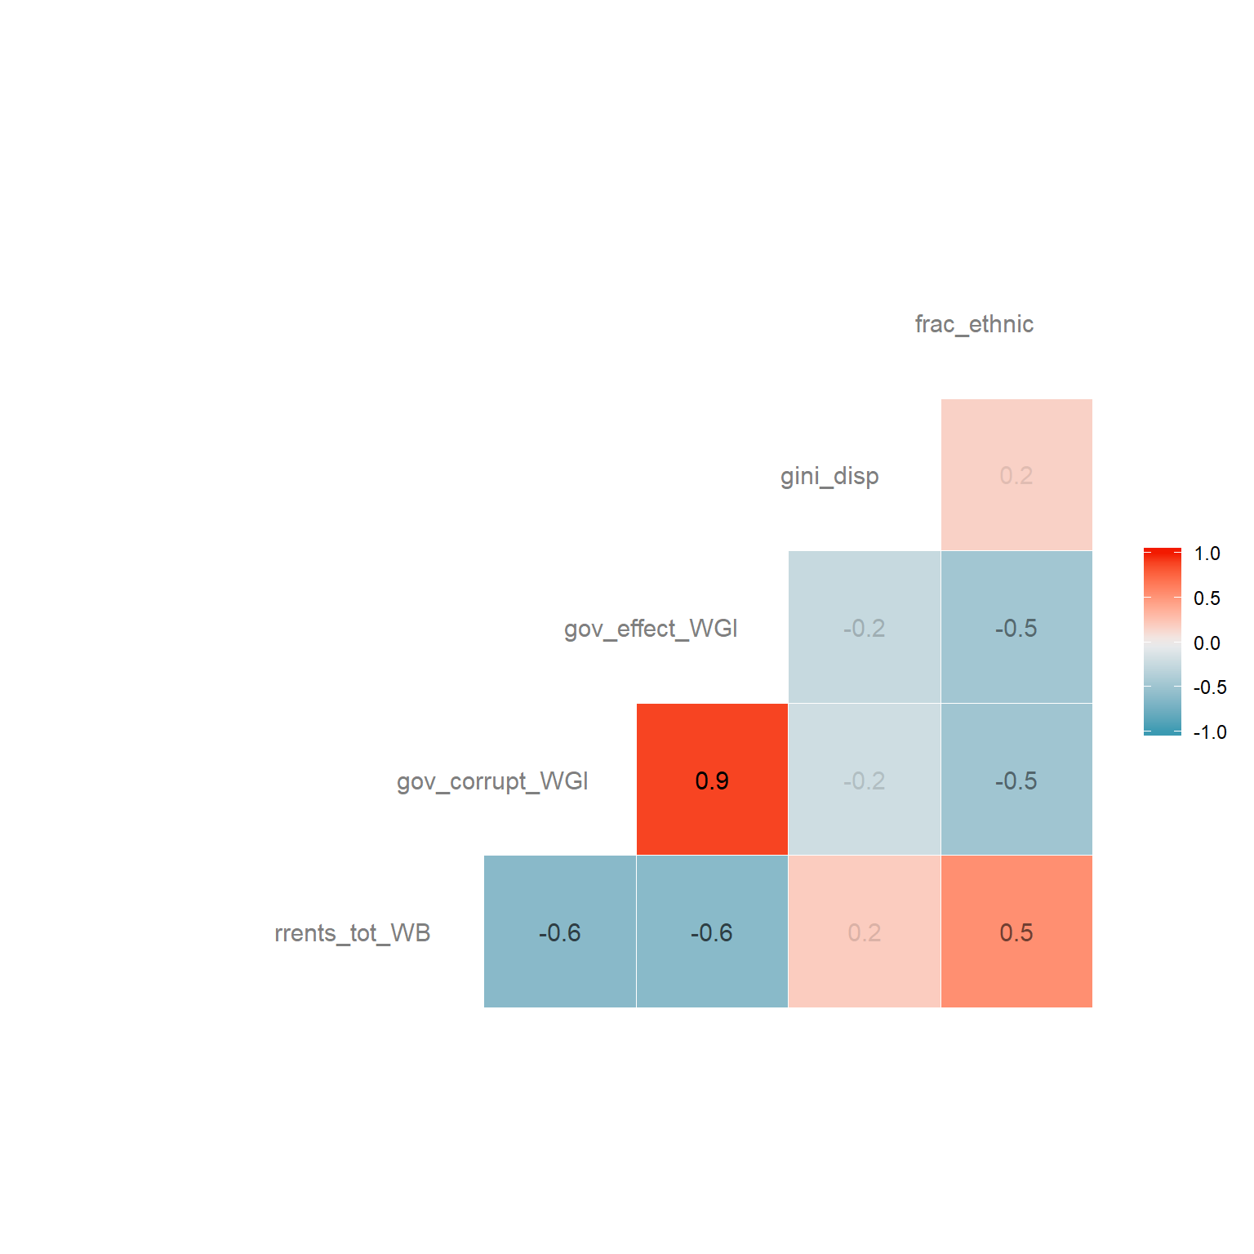

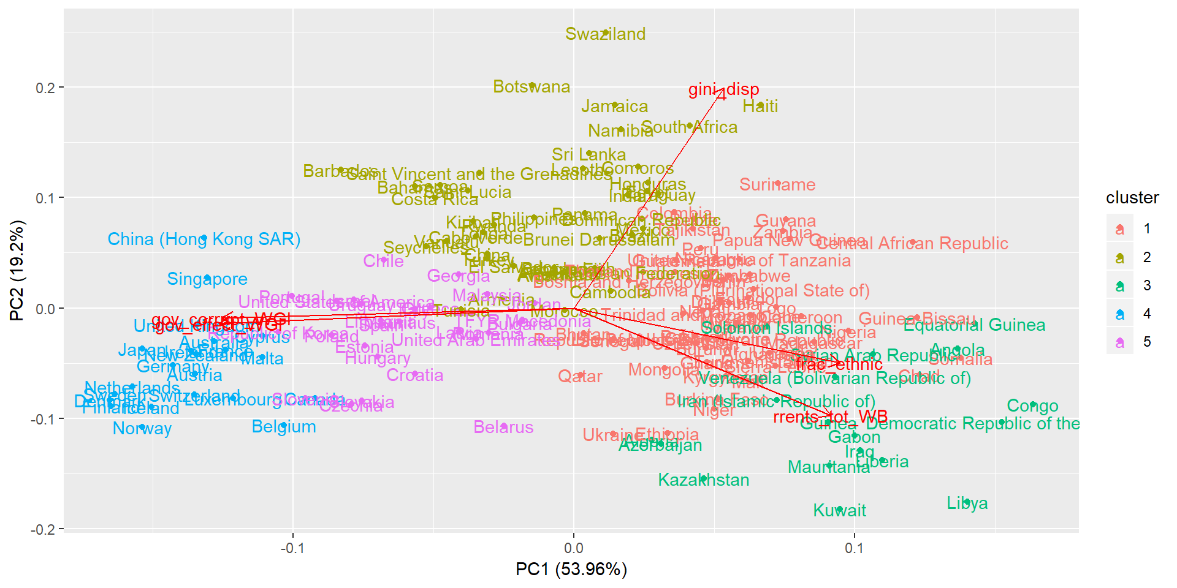

|  | **PC1** | **PC2** | **PC3** | **PC4** | **PC5** |
| --- | --- | --- | --- | --- | --- |
| Standard deviation | 1.64 | 0.98 | 0.82 | 0.76 | 0.30 |
| Proportion of variance | 0.54 | 0.19 | 0.13 | 0.12 | 0.02 |
| Cumulative proportion | 0.54 | 0.73 | 0.87 | 0.98 | 1.00 |
| Resource rents | 0.40 | -0.43 | 0.33 | 0.74 | -0.02 |
| Government corruption | -0.55 | -0.04 | 0.44 | 0.09 | 0.70 |
| Government effectiveness | -0.55 | -0.06 | 0.42 | 0.06 | -0.71 |
| Gini index | 0.24 | 0.87 | 0.36 | 0.21 | -0.02 |
| Fractionalisation | 0.42 | -0.22 | 0.62 | -0.63 | 0.01 |

* 1. *Regime types*

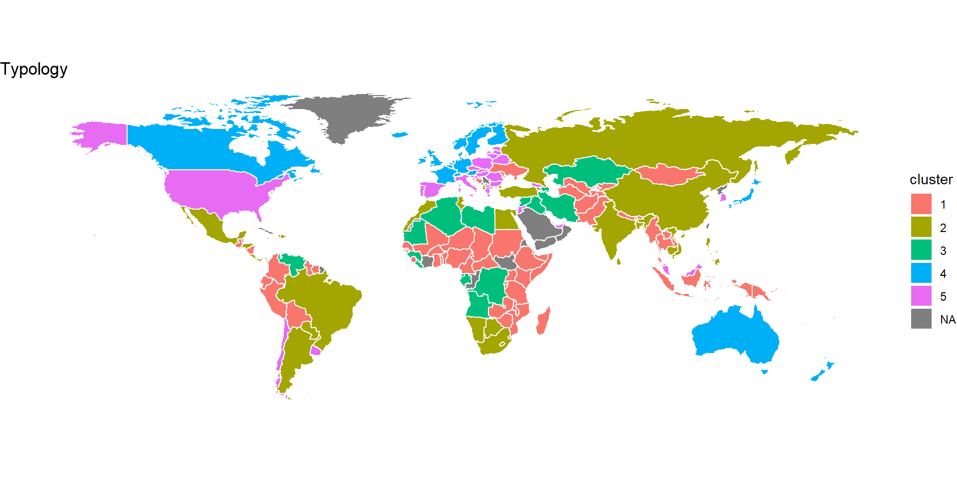

|  |  |  |  |  |  |
| --- | --- | --- | --- | --- | --- |
| cluster | 1 | 2 | 3 | 4 | 5 |
| rrents_tot_WB | 11.44 | 3.74 | 34.24 | 1.30 | 2.73 |
| gov_corrupt_WGI | -0.74 | -0.15 | -1.03 | 1.81 | 0.48 |
| gov_effect_WGI | -0.69 | -0.12 | -0.98 | 1.69 | 0.76 |
| gini_disp | 39.51 | 44.89 | 35.67 | 29.73 | 33.77 |
| frac_ethnic | 0.67 | 0.28 | 0.60 | 0.21 | 0.34 |
| countries | Afghanistan, Belize, Benin, Bhutan, Bolivia (Plurinational State of), Bosnia and Herzegovina, Burkina Faso, Burundi, Cameroon, Central African Republic, Chad, Colombia, CÃ´te d’Ivoire, Djibouti, Ecuador, Ethiopia, Gambia, Ghana, Guatemala, Guinea-Bissau, Guyana, Indonesia, Kenya, Kyrgyzstan, Lao People’s Democratic Republic, Madagascar, Malawi, Mali, Mongolia, Mozambique, Myanmar, Nepal, Nicaragua, Niger, Nigeria, Pakistan, Papua New Guinea, Peru, Qatar, Republic of Moldova, Senegal, Sierra Leone, Somalia, Sudan, Suriname, Tajikistan, Thailand, Togo, Trinidad and Tobago, Turkmenistan, Uganda, Ukraine, United Republic of Tanzania, Uzbekistan, Zambia, Zimbabwe | Albania, Argentina, Armenia, Bahamas, Bangladesh, Barbados, Botswana, Brazil, Brunei Darussalam, Cabo Verde, Cambodia, China, Comoros, Costa Rica, Dominican Republic, Egypt, El Salvador, Fiji, Haiti, Honduras, India, Jamaica, Kiribati, Lebanon, Lesotho, Mexico, Morocco, Namibia, Panama, Paraguay, Philippines, Russian Federation, Rwanda, Saint Lucia, Saint Vincent and the Grenadines, Samoa, Seychelles, South Africa, Sri Lanka, Swaziland, Tonga, Tunisia, Turkey, Vanuatu, Viet Nam | Algeria, Angola, Azerbaijan, Congo, Democratic Republic of the Congo, Equatorial Guinea, Gabon, Guinea, Iran (Islamic Republic of), Iraq, Kazakhstan, Kuwait, Liberia, Libya, Mauritania, Solomon Islands, Syrian Arab Republic, Venezuela (Bolivarian Republic of) | Australia, Austria, Belgium, Canada, China (Hong Kong SAR), Cyprus, Denmark, Finland, France, Germany, Iceland, Ireland, Japan, Luxembourg, Malta, Netherlands, New Zealand, Norway, Singapore, Sweden, Switzerland, United Kingdom | Belarus, Bulgaria, Chile, Croatia, Czechia, Estonia, Georgia, Greece, Hungary, Israel, Italy, Jordan, Latvia, Lithuania, Malaysia, Mauritius, Poland, Portugal, Republic of Korea, Romania, Slovakia, Slovenia, Spain, TFYR Macedonia, United Arab Emirates, United States of America, Uruguay |
|  |  |  |  |  |  |

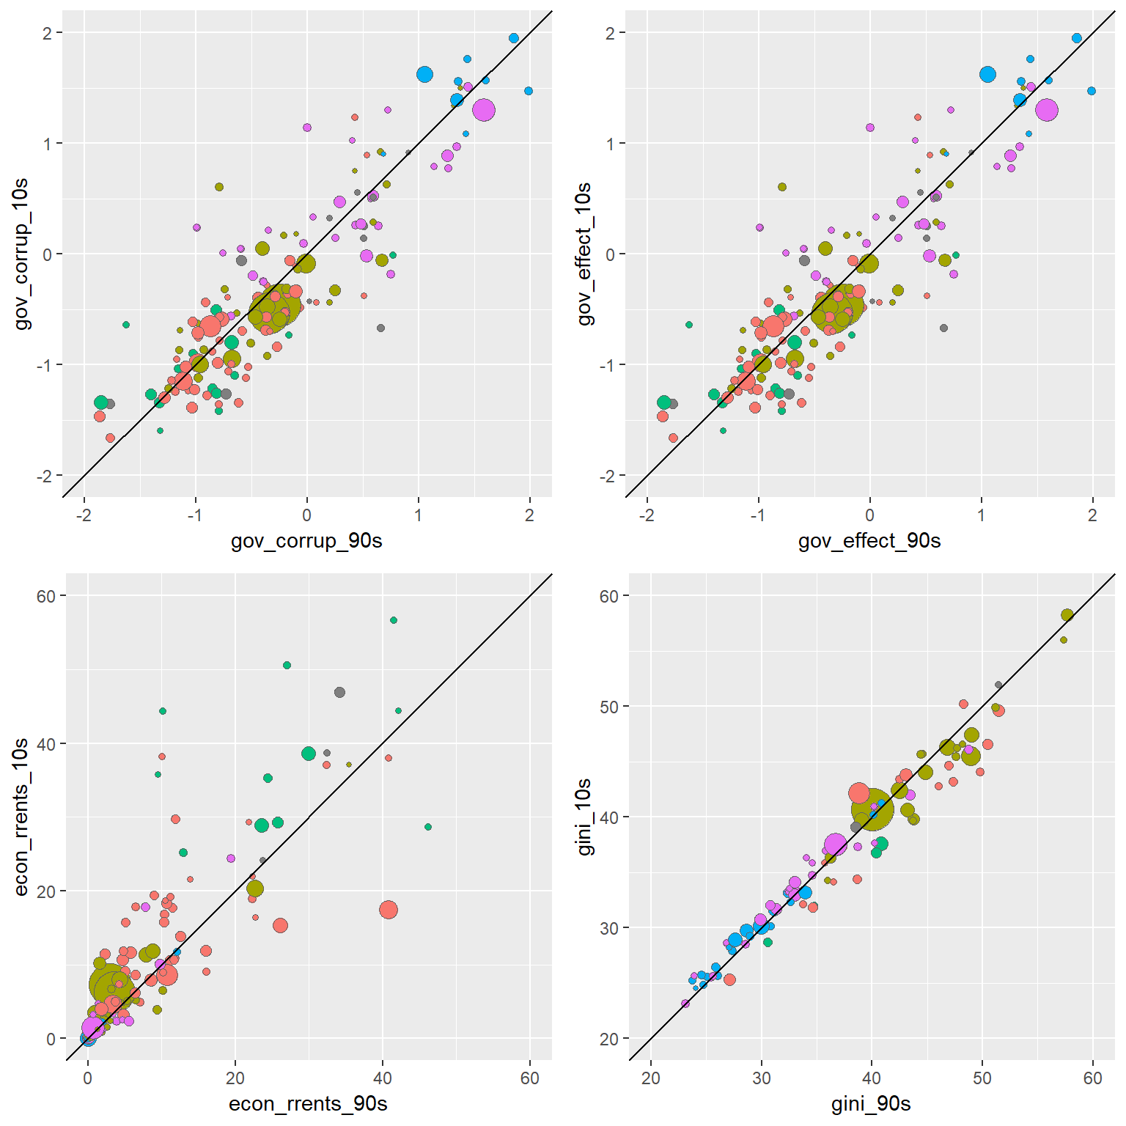

* 1. *Regime types and climate mitigation bottlenecks*

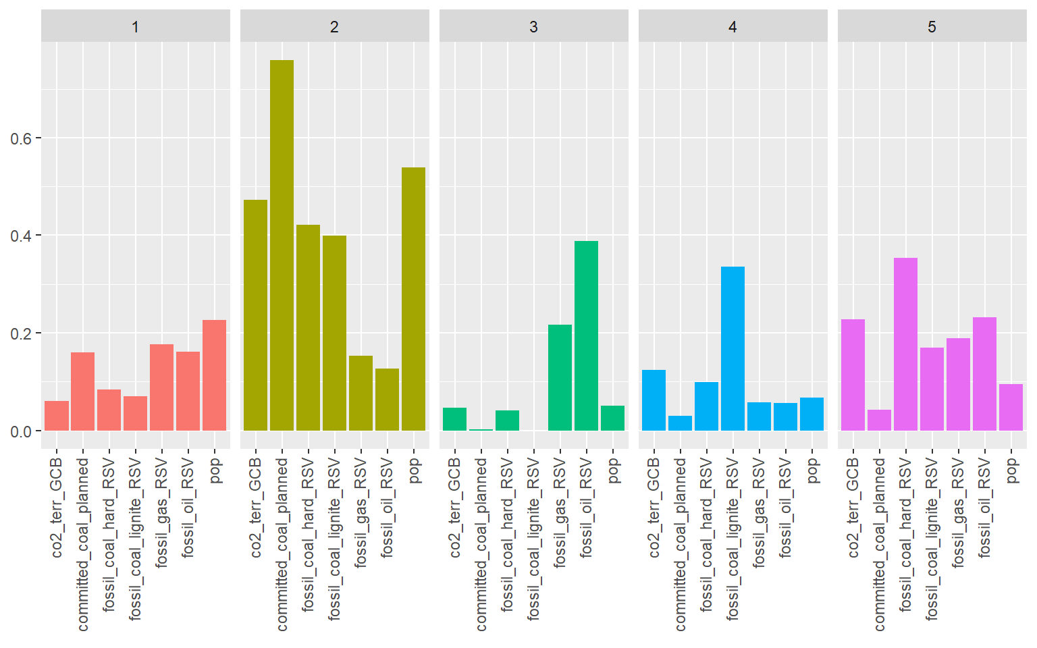

1. **Conclusion**

S. J. Davis and R. H. Socolow, “Commitment accounting of CO2 emissions,” *Environ. Res. Lett.*, vol. 9, no. 8, p. 84018, Aug. 2014.

C. McGlade and P. Ekins, “The geographical distribution of fossil fuels unused when limiting global warming to 2 °C,” *Nature*, vol. 517, no. 7533, pp. 187–190, Jan. 2015.